Lab 4

Tracy Michaels

1) 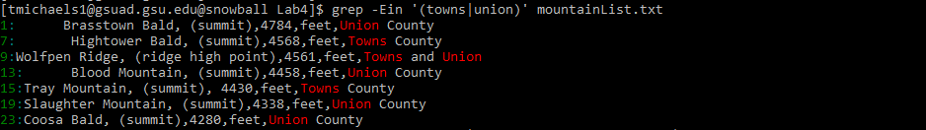

2)3) 

4)

A) 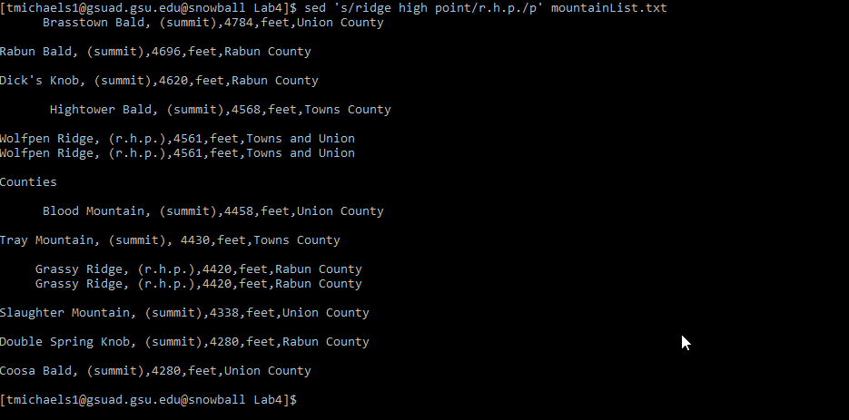

B) 

C) the -n flag suppresses the printing of the pattern space to only when there was a replacement being executed

D) this command will use substitution ‘s’ for the regular expression ‘ridge high point’ and replace it with ‘r.h.p.’ then print ‘p’ the pattern space, however since the ‘-n’ flag was set it will only print the pattern space if there was a substitution made.

5) 

6) 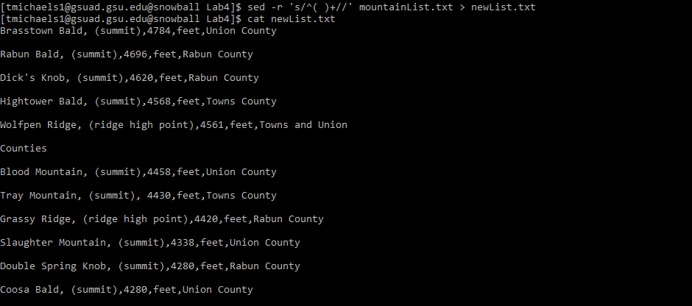

7) 

8) 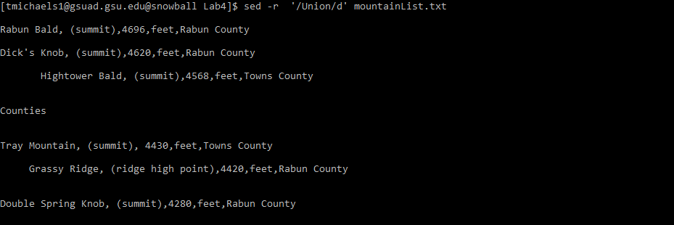

9) 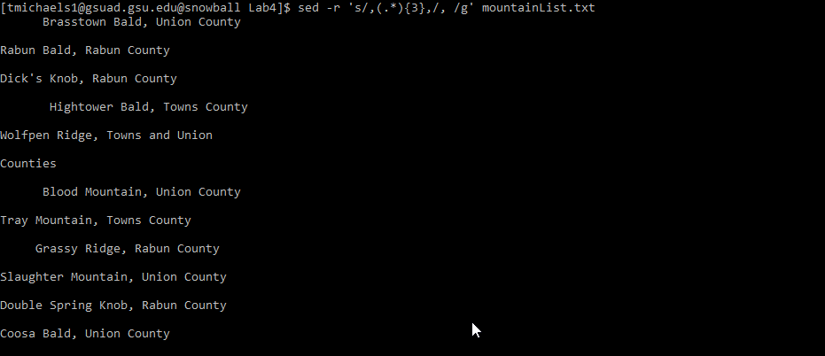

10) 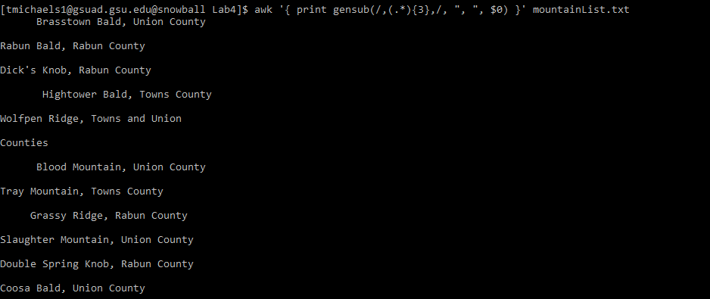

11) 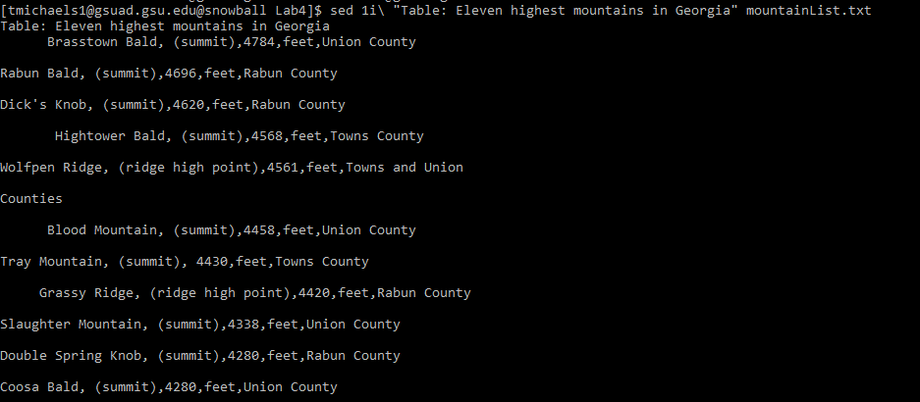

12) 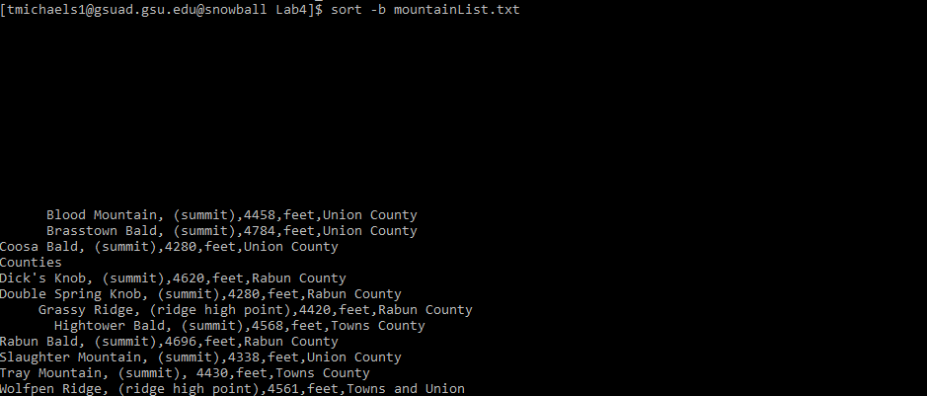

13) 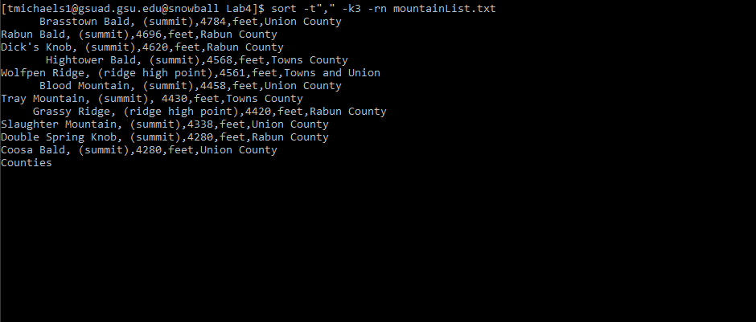

14) 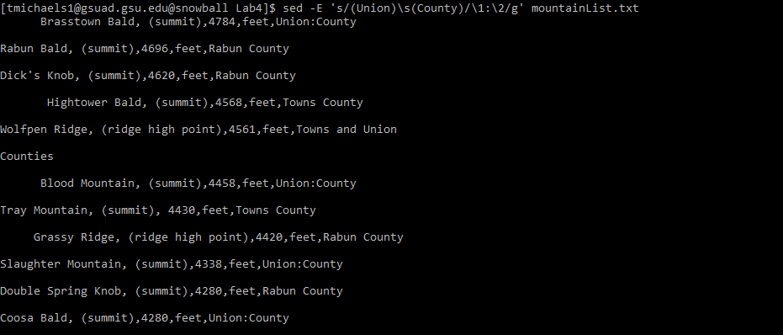

15) 